MAIDSTONE LAWN TENNIS CLUB CONSTITUTION UPDATE 2021

(Agreed at AGM held on 28th Nov 2021 with sufficient approved signatories obtained by 20th December 2021)

MAIDSTONE LAWN TENNIS CLUB
Poplar Grove, Allington, Maidstone, Kent

CLUB RULES, REGULATIONS AND GENERAL INFORMATION

- DEFINITIONS

The Club - shall mean the Maidstone Tennis Club

Senior Member - any person over the age of 18 years who has paid the current annual subscription

Junior Member - any person under the age of 18 years who has paid the current annual subscription

Honorary Member - any person elected to membership without fee following a duly approved motion presented to an AGM. The list of honorary members is updated as appropriate and is appended to these regulations as Appendix A

Court Allocation Chart - the chart showing the allocation of courts between Club use and public use, forming part of the lease agreement, and appended to these regulations as Appendix B

The Lease - the Lease granted by Maidstone Borough Council between the Council and Maidstone Lawn Tennis Club dated 15th March 1985

Premises - this shall mean the courts, netting surrounds and court equipment, the clubhouse, associated pavings and garden patio area

Non-Club Use - use of the premises by any person (member or otherwise) for purposes other than social tennis, club match play, club tournaments and club member coaching

- OBJECTIVES
The Club provides facilities for its members, arid other members of the community, of all ages and backgrounds, to play and enjoy tennis. The Club encourages participation, enjoyment, skill, competition, and sporting spirit in tennis.

The income and property of the Club shall be applied solely towards promoting the Club's objectives as set forth in these rules and no portion thereof shall be paid or transferred, directly or indirectly, to the Members of the Club.

To achieve these objectives, the Club has the power to borrow money and to obtain grants and other forms of assistance

Upon dissolution of the Club any remaining assets shall be given or transferred to another registered Community Amateur Sports Club (CASC), a registered charity, or the sport's governing body for use by them for related community sports.

- GENERAL MEETINGS
The Annual General Meeting (AGM) is held in the clubhouse (unless attending numbers are excessive), usually on a Sunday morning in October or November.

Notification of the AGM and business to be transacted must be mailed to members at least 21 days prior to the date of the AGM

Resolutions must be submitted to the Secretary. in writing, at least 28 days before the AGM. However, resolutions that propose changes to the Club’s Constitution, Rules or Regulations, must be submitted not less than 6 weeks before the AGM

An Extraordinary General Meeting (EGM) may be called for by submission of resolutions signed by at least 4 current members. On receipt of a legitimate call for an EGM the management must convene this meeting within 8 weeks, giving notice as stipulated for an AGM

A quorum at any general meeting will consist of not less than 25% of the members entitled to vote. Proxy votes will be permitted only if clear written instructions are submitted to the Secretary not less than 24 hours prior to the meeting

- MANAGEMENT OF THE CLUB
The direction and management of the Club shall be vested in a General committee, which shall consist of the Chairman, Secretary, Treasurer, Match Secretary, and up to 10 other members of the Club. The Committee shall meet as often as the business of the Club requires and at each meeting five members shall form a quorum. Any three members of the Committee shall be able to call a meeting of the Committee. The Officers and Committee shall be elected annually at the Annual General Meeting and shall be eligible for re-election. The Committee shall have the right to co-opt Committee members up to the maximum permitted number.

The Chairman shall chair every committee meeting and be responsible for the conduct of the Committee

The Secretary shall take minutes at each meeting to record accurately the conduct of the meeting and such minutes shall be presented to the Committee for ratification by the Chairman at the next subsequent committee meeting. The Secretary is also responsible for all correspondence relating to the Club to ensure that all members are duly informed on matters concerning membership

The Treasurer is to control the finances of the Club including incoming member subscriptions and match fees and is to make all duly authorised payments on behalf of the Club. Prior to each Annual General Meeting the Treasurer shall prepare a set of annual accounts which are to be audited prior to circulation to the membership and presented for adoption (or rejection) at the AGM.

The Membership Secretary shall be responsible for the preparation and publication of a list of all members and to record the payments of annual subscriptions, together with noting any arrears of subscriptions. Any member in arrears of subscription of more than three months may be liable to exclusion by the committee. Any member more than two weeks in arrears of annual subscriptions shall not be eligible for selection of matches or to vote at any meeting. All members over the age of 16 years are eligible to speak and vote at the AGM or EGM.

Trustees of the Lease will be selected from the committee and elected at an AGM.
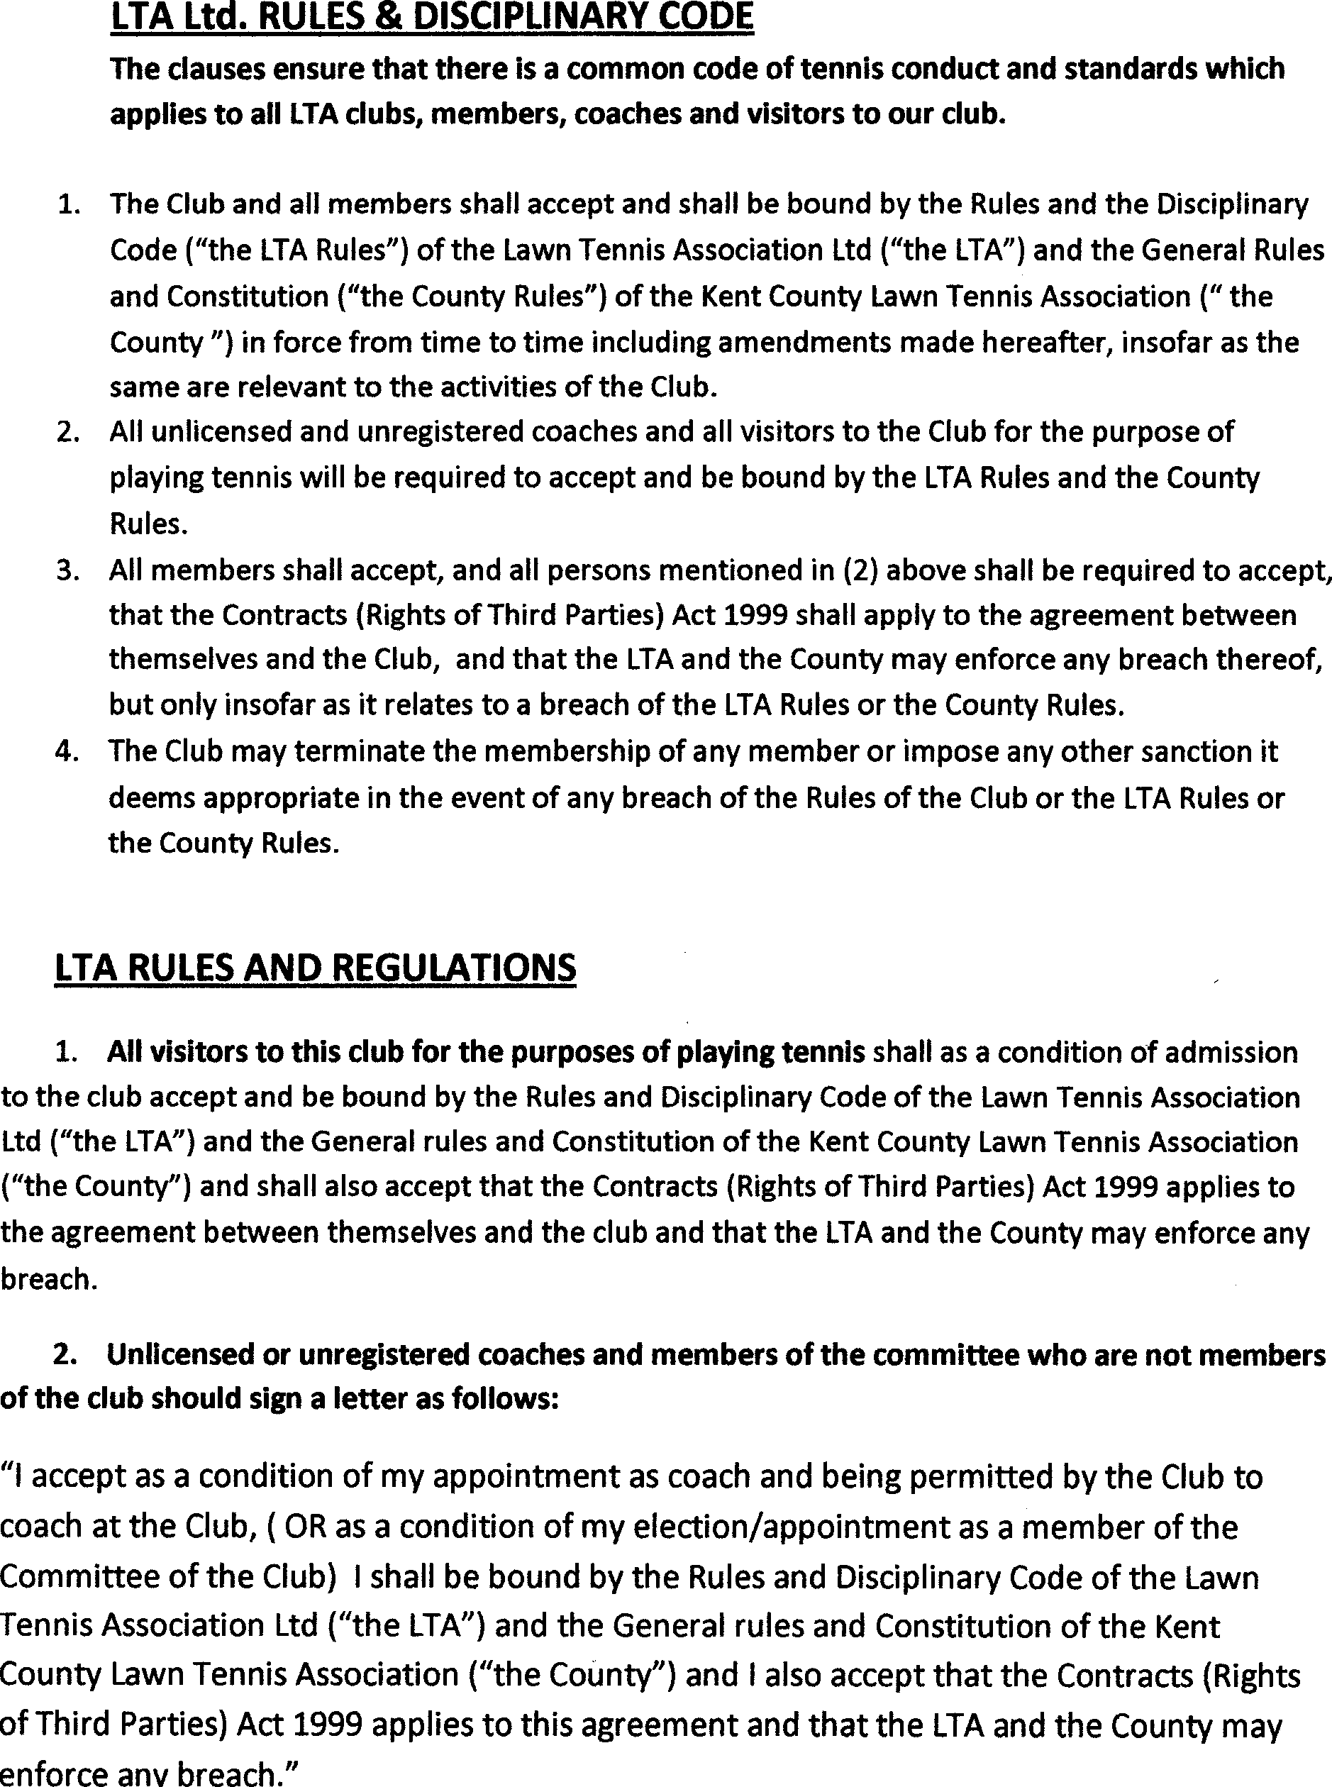

- MATCHES

The Match Secretary and any other persons as necessary shall be present at the annual match fixtures meetings and shall arrange the matches and venues with other clubs in any given division of any given league.

- COURT ALLOCATION CHART
- COURT ALLOCATION & USE

For allocation of courts for members/coaches please see the online booking screen-www.maidstoneltc.co.uk -book a court. Members may book up to 2 weeks in advance and can book up to 2 hours per day using the online booking system. The Admin booking team and Coaches have administration rights to book courts over longer periods of time to support the functioning of the club. The chair and club committee can at any time make any changes to the court allocation and use policy to ensure fair and equal access to the courts is available to members and will communicate this when required.
- Court Use

The online court booking system shows on which courts and when matches, social play and coaching are possible. To avoid misunderstanding members can therefore see which courts are possibly going to be used for matches and coaching. It also extends the number of courts designated for members to use during social play to Court 4.
Where Courts 1 & 2 are in use for matches we suggest that if necessary, members have the priority on Court 3. The gate can be closed between Courts 3 & 4 and the bottom gate opened into Court 4. This court can then be used for coaching or the public if necessary. Hopefully this will reduce the interruption to matches which caused the match players to request the gate.
Where courts normally reserved for matchplay are not required for that purpose they may be used for general play by members.
The court booking system is shown on our website www.maidstoneltc.co.uk and is regularly updated.

- Community Use
Under the terms of our lease (completed in 2015 for a period of 28 years to 2043) members of the public have the right to book and pay for the use of courts not being used for club purposes (if they are not currently being used by members of the public) on a permissive basis only, but such use does not confer any rights whatsoever.

Any person using a court for non-club use shall be regarded as a member of the public and the court must be booked and paid for prior to use. This is a legal requirement in accordance with the lease agreement.

As part of the lease agreement, the club pays a fixed annual fee to Maidstone Borough Council. This is reviewed every 5 years and based on revenue generated by public hire court fees in the proceeding 5 years.

We have a legal duty to collect money from our public visitors and divide it between ourselves and MBC. Would all members please assist us with this and record details on booking sheet provided in clubhouse.

- THE LEASE
The covenants of the lease must be adhered to at all times.

A copy of the lease shall be available for inspection within the clubhouse and/or on request to members. Serious infringements of the covenants renders the club liable from expulsion from the premises by Maidstone BC.

All members are required to treat the premises in accordance with the covenants of the lease and not jeopardise the continued existence of the club.

- DRESS CODE
Members and the public shall dress appropriately for a game of tennis and not undertake actions or styles of dress likely to give offence.
Only accepted tennis shoes that do not mark or damage the court may be worn.

- GUESTS
Members wishing to invite guests must comply with the following rules:
- Visiting guests must be accompanied by a host member, who shall be responsible for the conduct of the visitor;
- Members must sign the visitors book and shall be responsible for paying the Visitors Fee (as published on the noticeboard or on the clubs website);
- The same guest may not be invited for more than 3 visits per membership year;
- There is no limit to the number of guests which may be invited in any year subject to (c) above;
- No member may invite more than 3 guests on any one occasion.

- APPLICATIONS FOR MEMBERSHIP
Applications for new members should be made to any member of the Committee and will become effective as soon as confirmed by the Membership Secretary. Temporary membership on a monthly basis will be available at the discretion of the committee.

Membership of the Club shall be open to all persons irrespective of ethnicity, nationality, sexual orientation, religion or beliefs, or of age, sex or disability except as a necessary consequence of the requirements of tennis as a particular sport.
The committee may refuse membership or expel from membership only for good and sufficient cause, such as conduct or character likely to bring the Club or sport into disrepute. Appeal against such a decision may be made to an independent appeal committee of three to five club members, no member of which was involved in the original decision.

ACCESS TO THE PREMISES
Members other than junior members will be issued with a code to access the clubhouse and all members will be given an access code to enter the courts.

In the interest of safety junior members shall only have access to the clubhouse under supervision of a member over the age of 16 years

- APPLICABILITY

Membership of the Club implies acceptance of these rules. The rules shall be binding
on every member and any dispute arising from their interpretation shall be referred to the Committee, whose decision shall be final.

- Discretion

The committee and Trustees have complete discretion in interpretingg these rules and in any other matter not provided for in these rules.
- ALTERATION TO RULES

No alteration to these rules shall be made except at the Annual General Meeting or at an Extraordinary General Meeting.

